Meaningful Structures

Robert Cleary
MPHG
Dr. Lasner
Final Paper

Introduction

This paper arose out of my own experience. In 2013, I moved into a tiny house in the backyard of a brownstone in Brooklyn and I lived there in that space with my boyfriend for five years. The tiny house had been built in stages in 2009 and 2010 and formed a part of the collectively organized community, treehaus, formed in 2007 and which filled the brownstone. The tiny house was integral to and dependent upon the community and its significance is best understood in relation to that community. This paper will consider the ways in which the community constructed meaning in the midst of these interlocking dynamics.
Queer and other countercultural cooperative communities flourished in Brooklyn in the late 2000s and early 2010s. This flourishing was related to both economic and social causes. The recession of the period and the interruption this caused in the forward push of gentrification helped result in the existence of spaces. A reimagining of queerness, also, was occurring at that time as a response to the shifting social position of lgbtq individual in the larger society. This duality in the economic and social are seen in the relationship between queer and other countercultural communities and the dynamics of gentrification. Gentrification is driven both by economic and cultural factors; yet, the cultural aspect is often interpreted in terms of the arising of a ‘new middle class’ or, alternately, a ‘creative class.’ I will argue that these communities do not constitute an aspect of either a ‘new middle’ or a new ‘creative’ class. These cooperative communities that flourished in Brooklyn in the late 2000s and early 2010s were, instead, an effect of the hiatus in in New York City’s fourth wave of gentrification brought about by the economic recession beginning in 2007 and 2008.

Lost in Space

Over the past several decades, queer and other cultural theorists have become increasingly interested in such spaces as ruptures, borders, and interruptions. Planners, urban theorists, and architects are also interested in these spaces, if often towards the purpose of filling them in. The discipline of history has also become productively preoccupied with these spaces, which fact has informed my own approach to the subject.
The concept of ‘space’ as it is being used here is to denote the ways in which individuals and groups create possibilities for how they themselves and others who enter that created environment will act and interact. The space created in a bank or a post office is very different than that created in a public street or park, yet all these spaces encourage the practice of behaviors which fit comfortably into the dominant social discourses. Although it is a well taken caution that we must beware the danger of allowing ‘knowledge generated from elsewhere’ to be then “read into or onto a space … as if that were the source of the knowledge.” Concepts of space and of spatiality have been utilized not only by such well-known scholars as Henri Lefebvre, Michel Foucault, David Harvey, and Doreen Massey, but also much more widely over the past several decades. Feminist historians have pointed out the fact that “as much as the study of space informs our understanding of gender, the inverse is also true,” and that the study of gender and sexuality may also reveal how space is constructed and regulated. A queer space is one which does not fit so comfortably, or especially, which challenges these discourses and power relations. And, queering a space is a set of practices or social behaviors which in some way ‘corrupts’ the spaces’ character as fitting comfortably within hegemonic practices or seeks to remove it from such discourses altogether.
As gentrification involves a re-imagining and re-ordering of space along hegemonic heterodox lines, it may seem difficult to see the ways in which a queering of space could be commensurable with such a project. Yet, things do not always begin in the way that they end. Jasmine Mahmoud has described how “[f]rom 2001 to 2007 … Bushwick went from being a place where it was not possible to produce experimental theatre [a ‘pre-frontier’ space] to a place of avantgarde possibility” and, also records that almost none of the underground art galleries and performance spaces created in Williamsburg in the 2000s still existed by 2013. The neighborhood of Bushwick borders both Williamsburg, (in)famous as gentrified through largely cultural means, and Bed-Stuy, the neighborhood where I live. Mahmoud highlights how artists and artist’s communities created themselves in spaces seen and described by them as ‘frontiers’ in Williamsburg and Bushwick in the 2000s. Mahmoud’s uncovering of these discourses finds echoes also in the work of Suleiman Osman on the gentrification of neighborhoods bordering Brooklyn’s downtown in the 1970s and also in Neil Smith’s descriptions of the gentrification of the Lower East Side of Manhattan in the 1990s.
Using a metaphor which is entirely apt and profoundly troubling, queers and artists may have seen themselves as something like cowboys. Experiencing freedom and adventure, bringing a queer disorder to define a space entirely new to them. Yet this disorder would eventually facilitate the introduction of a new order, inasmuch as they were or came to be so situated in the hegemonic imaginary as to allow for a re-ordering of the space. They imagined themselves, and their acts of self-imagining was central to their imaginarial power. As Mahmoud expresses it: “[i]t’s as if Bushwick’s 10 percent white demographic made the neighborhood into a frontier, an imaginative blank slate on which to stage new work.” This is the re-creation of space through social imaginary occurs. In particular, in the white social imaginary, the space appears as ‘blank’ not existing in a positive sense, operating, imaginatively, as a spatial absence. After a certain number of artists, queers, or other pseudo-marginalized individual or communities, the space begins to take on a positive aspect in the white imaginary, it comes into fuzzy existence becoming more and more ‘real’ until it is, finally, no longer a ‘frontier’ at all, but is entirely within the conceptual apparatus of the white imaginary. This is the mechanism by which artists and queers often work to advance the processes of gentrification.
It may appear that the expansion of gentrification into north central Brooklyn neighborhoods as Bed-Stuy and Bushwick in the late 2000s and early 2010s was simply an expansion of the gentrification of Williamsburg which had taken place earlier. Yet, we will see there was a fourth wave of gentrification, described by Lees, Slater, and Wyly in their text, that was interrupted by the economic downturn beginning in 2007 and 2008. The establishment of performance arts spaces in Bushwick, Brooklyn, described by Jasmine Mahmoud, took place during this period of interruption, which is also the time which saw the flowering of queer and other cooperative communities in Brooklyn, the late 2000s and early 2010s. It is therefore possible also to interpret the flowering of queer communities in Brooklyn in the late 2000s and early 2010s both as an aspect of the cultural dimension of gentrification and also as a distinct movement with its own relationship to the forces and processes of gentrification.

A treehaus grows

In 2007, two friends began a cooperative living community in Bed-Stuy in Brooklyn. This community, treehaus, grew to one which averaged anywhere from twelve to fifteen members and which lasted for eleven years. The treehaus community was a collective household rooted in food sustainability, consensus decision making, and a celebration of queerness. The treehaus community formed a part of and was involved in multiple creative endeavors with several communities larger than itself. These included cooperative organizing, radical activism, and Brooklyn’s queer community. Indeed, there was a flowering of cooperative communities in Brooklyn in the late 2000s and early 2010s. Many of these were queer communities. The reason for the flowering of queer and other cooperatives in Brooklyn in the late 2000s and early 2010s was two-fold, encompassing the economic and the social.
It is not only individuals and communities themselves who give meaning to the spaces they inhabit and occupy. So also do such larger external structures as local, state, and other governments. Such residential structures as tiny houses can be viewed alternately as dangerous and illegal or as creative and beneficial. The significance of the treehaus community and of the tiny house it constructed in the backyard are tied up not only in the relational dynamics the community actively sought or was engaged in but also with the processes of gentrification and the changes these forcefully wrought. Despite the intentions of the founders or of the radically queer and anti-establishment nature of the community, no entity so situated in that period could have escaped interaction within the processes of gentrification. Yet, I am interested in whether there were aspects to the treehaus community and other queer and countercultural communities in Brooklyn in the late 2000s and early 2010s which constituted a set of social relations or meanings which can be understood as operating outside of and perhaps counter-to the socio-economic imperatives of gentrification.
In the mid-2000s, following the recession of the early 2000s, New York City’s economy grew along with the city’s population. Although there was an increase in housing being constructed, the need outstripped the demand. This was especially the case as much of the new housing was intended and built for the well-off and affluent. New York City’s economy began to witness a downturn beginning in 2007. Eventually, in September 2008, came the collapse which began the ‘great recession’ of the late 2000s and early 2010s. The cost of living in New York City has increased over the past decades, and the great recession may not have had much impact on that general trend. However, the housing market in New York City was affected. In 2010, new residential buildings which had stood half-completed and empty since the crash were still a common sight in Brooklyn. In 2008, there were over sixty thousand vacant rental units in New York City. Landlords may have kept rental units off the market in order to drive up the prices, but it is nevertheless the case that rental prices were lower in the late aughts then they have become since. The economic collapse of 2007 and 2008 which resulted in the great recession could help to account for the existence of slightly more affordable spaces in Brooklyn in the late 2000s and early 2010s which could help to explain the flowering of cooperative spaces during this time.
It is difficult to build collective organizations when rents are high because their existence and flourishing depends upon activity which occurs outside mainstream economic relations. Sarah Schulman, discussing the social aspect of artists creating ‘new ways of thinking’ through creative invention in community with others similarly engaged, observes that a basic requirement for this process to occur are affordable spaces for artists in which, “to live, have work space, and find time to make their work.” The same is true for radical political or social communities as these are similarly engaged in creative work which stands in opposition to and struggles against the dominant and discourses and imperatives of the mainstream. Treehaus existed simultaneously as an expression of counter-cultural energy, as an articulation of queerness, and as situated within the process of the gentrification of Bed-Stuy. Exploring the positionality of treehaus offers insights into the counter-cultural and queer communities of which it formed a part, and consideration of the lived experiences surrounding treehaus can reveal the relationships between these communities and the forces of gentrification. It is my contention that, while to understand the queer and other cooperatives of Brooklyn of the late 2000s and early 2010s only as agents of gentrification is to miss an important aspect of their significance, still, it is necessary to understand the ways in which the queer and other cooperative communities which I am concerned with discussing did in fact also play a role in gentrification.

New Queer in Town

The treehaus community encompassed multiple expressions of situated meanings. These included an expression of radical political and social agendas not infrequently found informing cooperative organizations and standpoints. As such, it was an expression of counter-cultural tendencies, including such sustainable practices as food-dumpstering and bicycle transportation. The community was especially defined by its celebration of a queer identity deeply informed and enlivened by these additional counter-cultural sets of meanings. I argue that it was the queering of queerness through a resituating of its meanings by interweaving itself with the above that gave the community its most significant significance.
By the first decade of the twenty-first century, queerness had become so widely socially accepted that queers struggled to define their marginality, their sense of their identity as lying outside of the mainstream, through engagement with radical politics – now that being queer was no longer, a priori, a radical act or positionality. This can be understood as a transformation in a particular kind of queer identity. Indeed, given that ‘queerness’ was initially a position or identity characterized by its intentional positioning of itself as in radical opposition to the mainstream, the gradual normalizing of queerness which has occurred over the past decades would seem to require such an intentional repositioning.
The social reinvention of queerness can be accounted for in part by those shifts that were taking place in the larger society, but were also the result of a dual strategy of queer visibility and gay normality. Visibility was not a new tactic, being rooted in the homophile movement of the mid-twentieth century. By the 1990s strategies of visibility intended to communicate
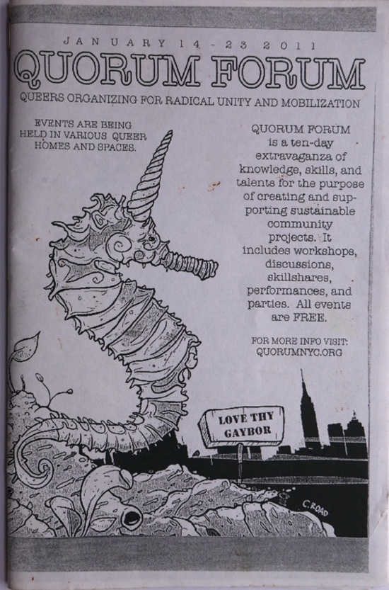 | 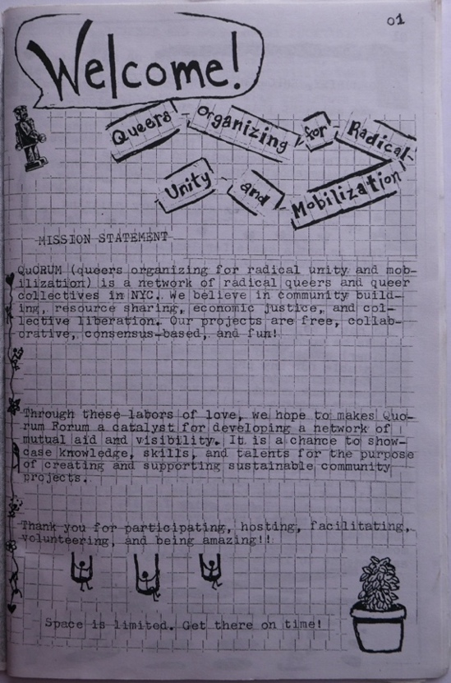
Program Cover first Quorum Forum, 2011. | Mission Statement, first Quorum Forum.

 | 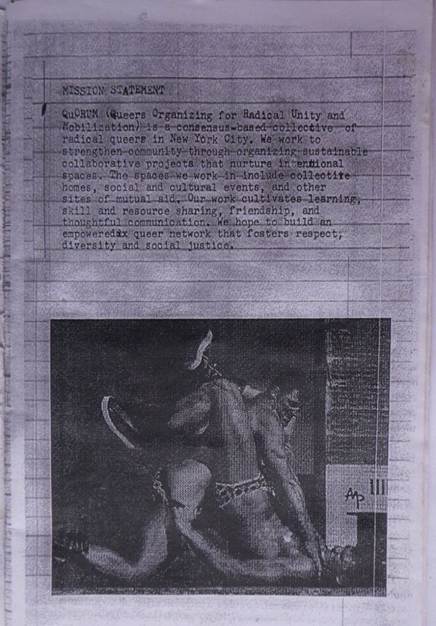
Program Cover second Qurom Forum, 2012. | Mission Statement, second Quorum Forum.

sameness and normalcy coexisted alongside those designed to be intentionally provocative, as those of the Lesbian Avengers, “whose parades, street actions, and manifestoes became real trendsetters for 1990s activism” Queer adoption of radical politics was no new thing. Yet, there had long also been a tension between more radical political stances and more conciliatory or assimilationist positions. Also, it was very much the case that toleration and, to varying degrees, assimilation was more available to some queers than to others. There occurred many acts of erasure of central meanings of queerness and of individuals whose lived experience embedded and enacted those significances in the recasting of queerness from an oppositional to an assimilated identity. Strategies of visibility, first served to empower queers themselves, then to effect a shift I public attitudes towards them, and eventually, it reinvented and redefined the meanings and positionality of queerness itself.
Queerness in earlier decades had made use of space and understood itself in relation to that space in largely practical ways, utilizing space much as others did, to enact communal life. The queerness was embedded in day to social interactions of simply moving through space. Being queer was defined as transgressive, in and of itself. By the close of the twentieth-century, growing acceptance of queerness made the simple acts of being publicly queer less universally transgressive. And, it has been noticed that “the effects of inclusion in the public sphere cannot but have an important bearing on the future of queer self-definition and its relation to the social.” As the reprobation attending the transgressive dimensions of queerness was increasingly attached to fewer and fewer individuals, this had the effect of offering a status of normalcy to some even as it had the effect also of intensifying the marginal status of those not granted the benefit of perceived normality. For those who wished to reject the status of normalcy a reinvention of queerness was necessary in order for that category of meaning to continue to carry the sets of significances it had done for them previously.
The relationship between queerness and space was still about occupying space as queer. What had shifted was the sorts of performativity involved. That is, appearing as and being responded to as queer in the transgressive sense now sometimes required creative new aspects. If being queer in and of itself was no longer a politically or socially radical stance, it could be reimagined as such through a creative bringing together of these impulses. This was accomplished through a creative bringing together of several impulses and creations of sub- and counter-cultural sets of meanings which were themselves radically transgressive. These included such anti-establishment practices as squatting, diy culture, and dumpster diving. Most strains of leftist anti-establishment counter-culture were traditionally uncomfortable with queerness, so that it sat sometimes uneasily within, sometimes adjacent or tangential to, and sometimes either ignored or disparaged by counter-cultural formations. There became a dialectical relationship between queerness and these counter-cultural formations at this time, each informing and transforming the other. The effect was that there was a renewed queering of space through the influence of bicycle transportation, dumpster-diving, and squatting. A space, different, yet no less queer. And, as the queerness itself was being worked out and work-shopped it became that aspect which gave impetus and meaning to transformations occurring also in other leftist counter-cultural communities. This was partly a response to the masculinist tendencies of many counter-cultural formations. The queerness was a corrective. It was a lever by which to shift social space’s inherent logics and embedded meanings and social interrelational dynamics towards enacting a differently gendered aspect.
Flipping the Script

The treehaus community was possessed of multiple and interlocking significances. If one of these was as an articulation of a particular kind of queer space, another was as an aspect in the larger socio-economic processes of gentrification. The faces of gentrification are legion and extend and develop over decades. A number of authors have commented on the relationship between lgbtq individuals and communities and gentrification; while artists and various countercultural communities, including squats, have also been heavily implicated as playing important roles in the gentrificatory processes. Yet, I will argue that new articulations of a radical queer identity being elaborated in communally organized spaces in Brooklyn in the late 2000s and early 2010s must be understood both separately from and also in and through their positions within the cultural dimension of gentrification. Yet, if a distinct queer community created itself in relationship with other communities and cultural imperatives at this time, then, it may be that the ways in which these communities were able to contribute towards gentrification may have been different than the ways in which earlier manifestations of gentrification driven by queer settlement patterns operated.
Gentrification constitutes one of the “key theoretical and ideological battlegrounds in urban geography … between the liberal humanists who stress the key role of choice, culture, consumption and consumer demand, and the structural Marxists who stress the role of capital class, production and supply … between the proponents of culture, preference and human agency, and the proponents of the imperatives of capital and profitability.” In explications of gentrification there have been two, opposing, conceptions presented. These two positions can be described as: “supply versus demand … economics versus culture … production versus consumption.” Loretta Lees noticed that much of the literature on gentrification settled at a “middle ground between demand and supply-side explanations” and she describes this middle ground both as an ‘impasse’ between the two and as indicative of the “underdevelopment of the productive tensions between the two.” In the two frameworks for understanding gentrification, the supply-side argument holds that gentrification is produced when capital ‘re-invests’ in urban areas from which it had previously ‘dis-invested’ while, in contrast, the demand-side argument elevates social factors over economic ones, where capital investment follows a ‘new middle-class’ who enact gentrification as a function of consumer demand. Although each has moved toward the other, a synthesis of the two explanations remains elusive.
Loretta Lees is a foremost scholar on the scholarship of gentrification. While she is critical of an over-reliance on the production side of the equation, Lees cautions equally against approaches which seem to move “the equation too far in the direction of consumption” with the result that “human agency is emphasized at the expense of structural conditions.” Lees quotes Chris Hamnett, and his observation that “the ‘choice, consumption and culture’ side of the debate has always had one foot in the material base of production with its changes and cultural manifestations.” Yet, she does this in order to state an important reservation. Lees is emphatic in her objection that in making this argument, the proponents take “the changes in the sphere of production as given, or else as themselves precipitated by changes in consumption, reproduction and/or culture.” Neil Smith’s theories do not suffer from lack of attention to the sphere of production. In fact, Smith raises the concern that for some, “it is less a question of developing the connections, inherent in gentrification, between economic and cultural shifts, resulting in new urban geography. Rather, in this vision culture virtually supplants economics, and agency can be distilled down to the narrowest philosophical individualism.” Nevertheless, as Loretta Lees, observes, Smith’s conception of gentrification did change over time from one more strictly production based to one which recognized consumption as a factor. Yet, she argues, although Smith acknowledges that “new urban patterns now unfolding do involve the construction of ‘consumption landscapes’ in the city” he rejects that this must “imply that urban geographical change is now somehow demand led.” Lees criticism of Smith’s position is that while “Smith writes that it is time to include a demand notion in Marxist analyses of gentrification, yet an adherence to the priority of production and accumulation makes this difficult.” This difficulty, Lees argues, arises out of the fact that it is “difficult for Smith to include a consumption-based argument in his thesis without first theoretically accepting the emergence of the new middle classes.”
As described by Lees, this new middle class is possessed of several defining characteristics. One is an ‘ambiguity’ arising out of an uncertain class position; an ambiguity, “reflected in the architecture of gentrified property” where “external façadal display denotes candidature for the dominant class (bourgeoisie), while internal renovations attempt to distance the middle class from the lower orders.” This new middle class is also defined by “its ability to exploit the emancipatory potential of the inner city, and indeed to create a new culturally sophisticated, urban class fraction, less conservative than the ‘old’ middle class.” Lees observes that, in this interpretation, “[g]entrification is deemed to be a spatial manifestation of these new cultural values.” We see here an attempt to find a concept which would allow a synthesis of supply-side and demand-side theories of gentrification. A sort of unified-field theory for gentrification.
What is at question is the capacity of cultural patterns to operate not simply as corollary aspects of income and rent levels in driving gentrification but in itself being a causal agent, in the differences between “education and occupation as indicators of gentrification” as over and against education and occupation as drivers of gentrification. Lees offers the criticism that Smith’s production side explanation for gentrification falters in the face of the new middle class. To the extent, however, that this synthesis of consumer and production theories of gentrification are brought together in the concept of the new middle class where gentrification is understood as ‘a spatial manifestation’ of ‘new cultural values’ relies upon reading shifts in the aesthetic terrain determined by and supportive of that new middle class where “the aesthetic signifiers of upward social mobility … contribute to the process of gentrifiers ‘reclaiming space,’” it may seem difficult to square the emphasis on how with the queer, diy, and freegan aesthetics which characterized so much of the movement I have described. Yet, gentrification is an uneven process, happening in stages over decades, and there is another concept in the tool box of gentrification theorists which may help to bring together the economics versus culture threads of the debate, that of the marginal gentrifier.
Marginally Yours

Marginal gentrifiers don’t fit easily into either the production or the supply side paradigms of gentrification. It has been argued that although marginal gentrifiers may be lacking in that fiscal capital which would “either align them with the upwardly mobile yuppies, or that they would need in order to resist what some regard as the highly predictable – and almost teleological – displacement at the hands of the bourgeoisie,” they are nevertheless “rich in cultural capital.” Queers and artists have, often been identified as epitomizing the marginal gentrifier. And, it is certainly true that queers have been at the forefront of gentrification along with artists and other pseudo-marginalized populations. Neil Smith noticed that “gentrification is a process, not a state of existence, and in good realist fashion it ought to be defined at its core than at its margins.” Nevertheless, it is interesting often to study the margins. And, “the importance of ‘marginal gentrifiers’ is not that they define gentrification but precisely that they are marginal to a process defined as the change ‘of inner-city neighborhoods from lower to higher income residents’ … Marginal gentrifiers are important, especially in the earlier stages of the process, and may well be distinguished by cultural attributes and alternative lifestyles … but to the extent that the process continues and property values rise, their ability to remain in the area depends less on their cultural than their economic portfolio.” So, queers may lack the resources necessary to carry on the processes of gentrification, but they may be well-situated to begin the process. At the same time, it is not infrequently the case that downwardly mobile and counter-cultural individuals or groups comprising such members are able to leverage capital, both social and fiscal, sufficient to operate at the margins of gentrification. It may not be in the buying of townhouses that such individuals are useful to those processes, but rather in their capacity to occupy certain liminal spaces which can work to maintaining the forward momentum of gentrification, particularly in its earlier or interrupted stages. It is in this, their capacity for liminality, that much of the work performed by the ‘hyper-marginal’ gentrifiers I am proposing is done. The distinction between marginal and hyper-marginal gentrifying populations, I would argue, is that the first constitutes a consumer based cultural assemblage and the second a subcultural countercultural formation.
Hyper-marginal gentrifiers contribute to shifting the imaginary which surrounds a space in the minds of those who will later follow. An imaginary operates “as a field of meanings” and a social imaginary “provides an organized set of interpretations” which “produce specific relations of power through the production of distinctive social identities.” Neil Smith may have been talking about economic and productive forces when he observed that “[e]conomic expansion today no longer takes place purely via absolute geographical expansion but rather involves internal differentiation of already developed spaces.” It seems to me that the kind of work we are talking about in reworking the imaginary can be understood in similar terms, as a sort of differentiation. One of the ways in which the internal differentiation of already developed spaces is achieved through the reworking of imaginaries. The employment of cultural and subcultural narratives and identifications allows for more effective demarcations and elaborations of space than economic forces could alone achieve.

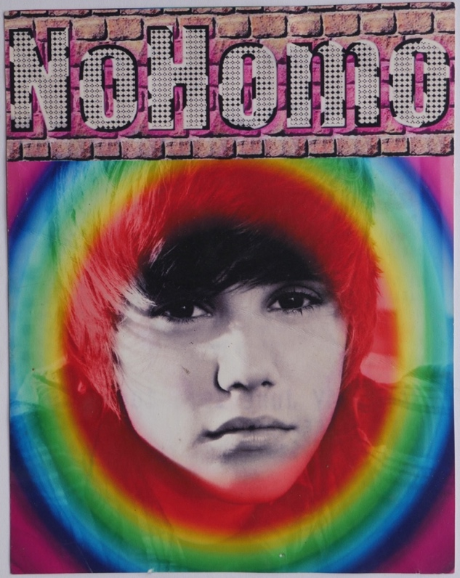 | 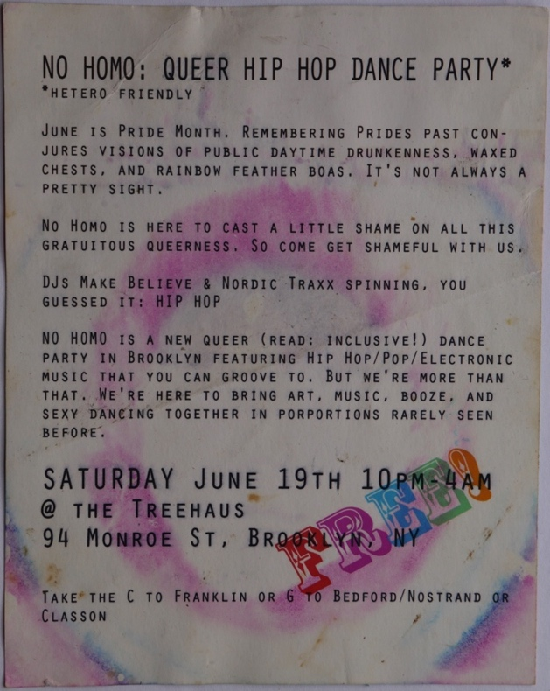
‘No Homo’ party treehaus, 2010. | Reverse of ‘No Homo’ flyer.

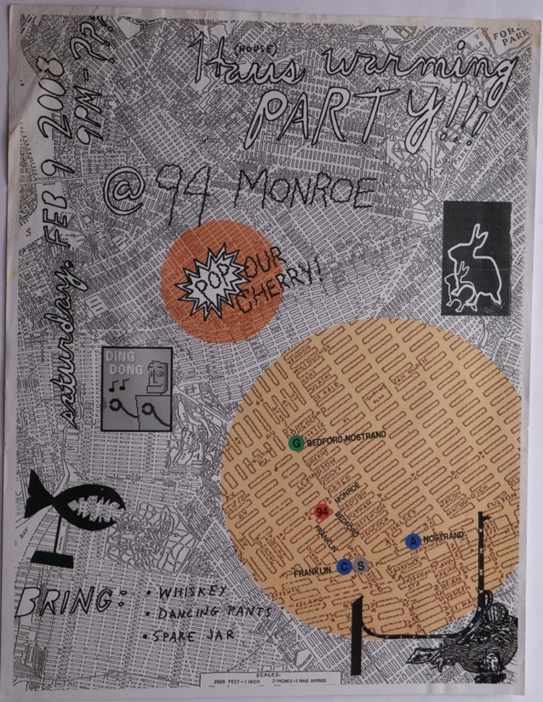 | 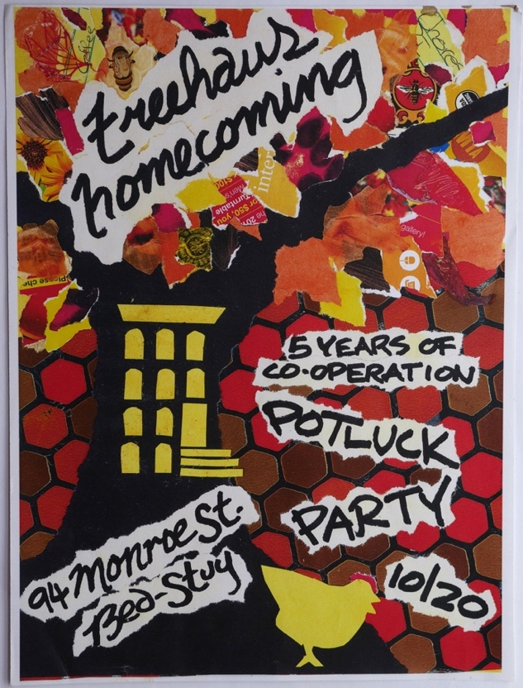
‘Haus Warming’ party flyer, 2008. | Five-year anniversary party flyer, 2012.
In their book published in 2008, Lees, Slater, and Wyly describe a fourth wave of gentrification in the mid-2000s following a brief recessionary period at the beginning of that decade. Bedford-Stuyvesant was one of the neighborhoods most strongly affected by this, fourth, wave of gentrification in New York City. Their book would have been going to print just as the stock market was collapsing and the fourth wave of gentrification was presumably cut short by the great recession. This, slowdown or pause, in the gentrification of Bed-Stuy in the late 2000s, the same moment as the treehaus community was founded, allows us to see the ways in which efforts towards opposing the capitalist socio-economic system may nevertheless be used to that system’s ultimate advantage. As has been observed of bohemians, “who live simultaneously within ordinary society and outside it,” sharing “a marginal existence based on the refusal or inability to take on a stable and limited social identity,” the countercultural and queer cooperative communities of late 2000s Brooklyn occupied a space both inside of and outside of society. This operated as a bridge allowing the imaginary to gain a foothold. Thus, the re-imagining and re-inventing of queerness I’ve postulated may be seen to have also reinvigorated the capacity of queers who attempted to reject the normalcy on offer. Hegemony makes its offers in ways not so easy to refuse, it would seem. Despite the reimagination of queer space in dialectic with anti-capitalist countercultural formations which treehaus embodied, this did not ultimately prevent the community from contributing to the advancement of the gentrification of the neighborhood.

The Structures We Build

We build structures, material and relational. Some of the structures built by the communities who made and inhabited the queer and other communes of Brooklyn in the late 2000s have been analyzed by others. I have described how in the late 2000s and early 2010 there occurred a syncretism among queer and other countercultural movements. One question that has surfaced again and again is the interrelation between the cooperative communities I am describing and other structures. It has seemed to me that if I could find points of difference or comparison, that this might allow me to make better sense of the dynamics I am describing. It has seemed evident to me that the treehaus community and others to which it was interconnected in manifest ways were best related to countercultural and left organizational spaces. There is an important relationship between how people in a community occupy space together, the value systems they put into practice, the wider relationships they build and maintain, and the effect they have. In doing research for this paper, I came across several examples of relational structures that felt resonant to the queer and countercultural communities I am describing. One of these is communities built around squatting.
The work of John F.C. Turner draws attention to the importance of anti-hierarchical, bottom-up, constructions of physical space. Turner points out that only when all users, “whether an individual or a small organization, makes its own entry and carries out its own, often unique, program … can all available resources be used or mobilized – whether they are small, scattered, and irregular plots of land; odd lots of otherwise wasted materials; un- or under-employed people; or simply the imagination and initiative to combine any of these.” I view the tiny house in which I lived both as an instantiation of Turner’s bottom-up approach to democratizing space and also as a queering of space, as an act of interrupting space made by the treehaus community. These communities were not a part of a new middle or a new creative class, but were rather representative of a ‘new queer’ community coming into existence in a process of dialectical creation through engagement with other countercultural communities and traditions. Yet, as will be shown also, this did not prevent the treehaus community from being an aspect of the larger processes of gentrification. In any system of ebbs and flows, the ebb is just as much a part of the system as the flow. Still, the structures that community built, because they came out of a space which was distinct from the main trend of gentrification, do hold value in attempting to understand ways in which we might respond to Turner’s appeal for a bottom-up approach to housing.
I have argued for a synergetic relationship between queer and other countercultural movements such as squatting and freeganism. While freegans may be “best known for publicly ‘dumpster diving’ … freegan practices also include gardening in abandoned lots; creating and repairing bicycles, clothing, or furniture from discarded materials; foraging for wild food in urban parks; and limiting paid employment in favor of full-time activism.” Many of the practices of the queer and cooperative communities I am concerned with describing here bear as much in common with such practices as they do with such ‘traditional’ queer practices as communal dance practices and publicly cavorting in fabulous dress. The same author makes a further observation that “[w]hile freegans’ worldviews were undoubtedly shaped by their early involvement in other social movements and activist networks, freegans nonetheless experienced their motivations to act morally as a permanent, intrinsic part of their identities.” The fact that it is not uncommon for members of countercultural movements to experience their participation in such movements as ‘a permanent, intrinsic part of their identities’ being similar to how many queers experience their queerness facilitates their reimagining and recreating of communities through engagement with such counter-cultural milieus.
The second socio-political practice I would like to mention is squatting. In discussing squats, it is easy to get distracted by their illegality and anti-establishment character. In many accounts of squats the most fascinating and discussed aspect can be the occasions upon which hundreds of police storm a besieged building against a valiant, if almost invariably unsuccessful, defense mounted by residents. They are resistant in the extreme of their necessity, yet resistance is intrinsic to their being. The community I lived in was not a squat, yet it bore resemblances. Hannah Dobbz defines the essence of squatting as, “occupying an otherwise abandoned structure without exchanging money or engaging in a formal permissive agreement.” The relationship of the community to which I belonged to the space it inhabited did not initiate itself as squatting, that is, as using or inhabiting the property without a formal agreement with the property owner and/or payment for the use or habitation. It is also worth noting that many sorts of spaces which operate as squats in much of the rest of the world are unable to do so in the United States and still bear much resemblance to the functions served by such spaces even while paying rent. It is also true that by the time the community’s habitation of the space concluded, it had come much closer to squatting in its dynamic involving payment for the space as well. The later history of the community is, for the most part, outside the scope of this paper. However, it may be noted that in 2013 the property was sold to a new owner and the relationship between the community and this new landlord deteriorated over the next several years. Following several illegal, and hence unsuccessful, attempts at evicting the tenants, the residents ceased paying rent to the landlord and the formal agreement between the community and the property-owner lapsed. It is also worth noticing that the tiny house structure which I and my boyfriend inhabited has a somewhat squattish nature, in its quasi-illegality, built nature, and ‘occupation’ of land. If one were to consider the structure that I lived in only as a tiny home, shorn of its surrounding and embedded meanings, it may radically affect the meaning given it. In the social imagination of the early twenty-first century United States, such homes have been characterized, almost fetishized, by popular television shows. Yet, the manifold relational significances of tiny houses also include those as diverse as accessory dwelling units, ecovillage communities, and as homes for the formerly homeless.
Beyond these aspects however, squatting is possessed of a central aspect which gives it its primary resemblance to the cooperative communities I describe. It has been considered definitional of squatting that it involves the effort of ‘improving’ the land or property. This dynamic is also central to collectively organized communities. The relationship of the residents to the space is one of creative transformation. What is the difference between people living in a space, over a period of time themselves improving a space, and, simply paying a contractor to do the work, and, in what ways are these not the same thing? What is it that is created in the creation of a community, and, can its construction be considered as comparable or relatable to the physical improvement of a space? What is the relationship between housing and identity, and, what does it mean to live in a community? Improvement as a creative act, one which adds value
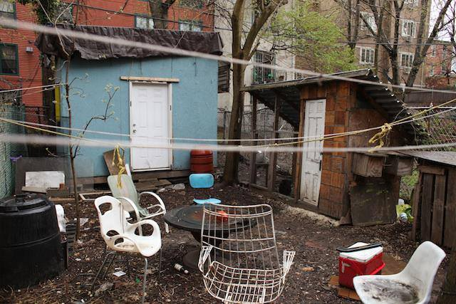
The tiny house and backyard of treehaus.

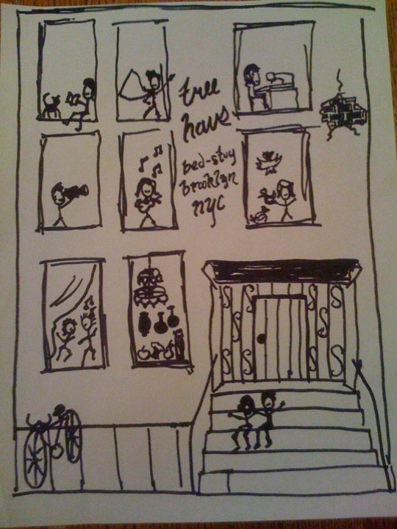 | 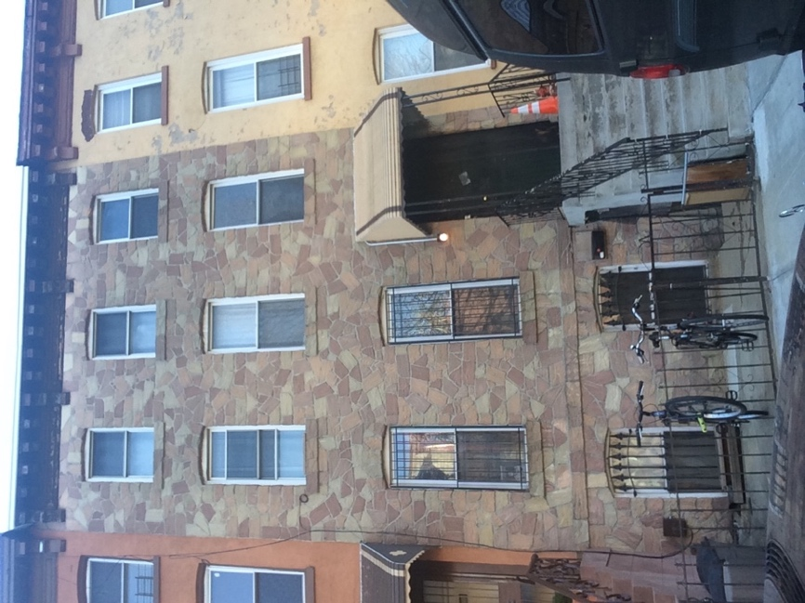
Drawing of treehaus, 2010. | The front of the house.
through collaborative work requiring social interaction is a central aspect of squatting and cooperative communities. If we understand squatting as centrally concerned with ‘improving’ the building or property being squatted, then, this also raises the question as to whether the creation of community and community structures might be considered a form of improvement. Hannah Dobbz describes her experience of living in a squat in New York City as closely resembling the “European idea of squatting as liberated social center.” The social centers to which Dobbz refers have been described as spaces where “creativity is unleashed and attention to the local arena is unhindered … [and which] can have any of a variety of different relationships to wider social movements.” I consider it an essential and definitional aspect of the queer and countercultural spaces I am describing that they exhibit such relationalities. The dynamic I am referring to has been described as ‘collective effervescence’: “a transformation in patterns of interaction within a community which stimulates and excites those involved and which breaks down old conventions, generating new ones and also new identities, ideas and values.” Another author has referred to dynamics where, “the intersection of publics, spaces, and identities can begin to delineate a new urban arena for democratic action that challenges normative definitions of how democracy works.” But, there are other sorts of descriptions that might be equally or more apt, and I am interested in exploring the relevance of these as well.

Knowing me, Knowing you

It must be recognized that it is not only radical artistic and countercultural communities which are capable of forming creative or dynamic relationships. Relationality is also a marker of those marginal gentrifiers I have tried to argue as distinguishable from the class of ‘hyper-’ marginal gentrifiers I am proposing. It has, for instance, been observed that “early gentrifiers are part of social networks and they move into an area on friends’ recommendations and to be close to them.” My research has turned up two commonly applied frameworks for understanding the dynamics of such social networks involved in gentrification. The first is Sharon Zukin’s ‘artistic mode of production’ and the second is Richard Florida’s ‘creative class.’ Florida’s creative class envisages a scenario in which a segment of the citizenry ‘revitalizes’ the city by dint of creating a new economic force and in the process creates itself as a new class in society. Zukin’s artistic mode of production, on the other hand, pictures the impetus as coming from the demand of the wealthy classes for a certain kind of cultural product for their consumption. Zukin’s paradigm can, perhaps, be compared with more facility to the rise of the service sector than to the rise of a new dominant class.
I, earlier, mentioned Sarah Schulman’s claim that in order for artists to create ‘new ways of thinking’ it required affordable spaces in which to live and work. It is interesting to juxtapose Schulman’s reflections with Sharon Zukin’s description of the origins of gentrification in the Williamsburg neighborhood which: “began with a low-rent and somewhat dangerous neighborhood, enabling moneyless twenty-somethings who wanted to be artists to form scenes, ’zines, and experimental art forms with little market value.” In many ways Schulman and Zukin are saying the same thing. In places, they almost do. They each have a critical edge to their analysis, but differently nuanced. Zukin describes the artists occupying affordable spaces in Williamsburg in the 1980s as ‘cultural entrepreneurs’ whose clubs and galleries “became social centers for both fellow artists and young cultural consumers.” This is a different conception than the vision of artists as creators of new ways of thinking put forward by Schulman. And, it is different from such concepts as ‘collective effervescence’ I have portrayed as animating a queer cooperative. It is, of course, not that Zukin does not recognize the creative energies involved, it is that she sees more than this. Schulman and Zukin exhibit certain differences in sensibility in their analysis’ of gentrification. Zukin is, in this field, the recognized expert. Yet, Schulman wields a queerly critical eye that I find beguiling.
The artists galleries and performance spaces were certainly not in most cases the direct cause of the closing of the factories of north Brooklyn. While cultural institutions can and do have such effects, small artists collectives and queer freegan communes are clearly not the same thing as a major museum or research university. Nevertheless, we must be sensitive to the relations existent between the economic and cultural forces as they interact in producing gentrification. Gentrification is a multi-faceted process occurring, often, over decades. One which looks very different at different stages in its processes. The artist and the queer may indeed be the thin end of the wedge. Cities are disinvested in. Factories close as production is moved to another geographic region. Population declines because suburbs are built through a combination of speculative building and government subsidy. This, disinvested-in, city becomes an historical fact. We should not confuse responses to the historical fact for causes. Nor should we become confused in delineating difference among responses. To say that both the ‘brownstoners’ of near downtown Brooklyn in the 1970s and the artists communities of north Brooklyn in the 1980s were both responses to the historical fact of the dis-invested city, is not to say they are the same thing.
The story told at the time is a part of the process. Stories of pioneering and homesteading were central to the ‘brownstoners’ who moved to neighborhoods of Brooklyn bordering downtown in the 1950s through the 1970s. It may be that such ideas as artist communities creating ‘new ways of thinking,’ or queer communities challenging ‘heteronormative’ social institutions and dynamics are as central to the gentrification of north and north-central Brooklyn decades later. Richard Florida’s creative class, mentioned above, “is very wide and encompasses 30 percent of the labor force, including workers in such areas as science and engineering, architecture and design, arts, music, and entertainment as well as those in business and finance, law, and health care.” In Florida’s conception, this diversity is understood as forming a whole. Yet, it has also been observed that “[w]hat holds ‘bohemians’ and ‘creative professionals’ together is not class at all, but their participation in the process of gentrification … [in which] they each play different roles, at different stages, and they each benefit unequally.” There are, potentially, as many differences as there are points of similarity in the cultural formations which participate in and each in their own way enable gentrification to proceed. Emphasizing those differences may assist in unraveling the structure they are constitutive of.
Conclusion

For five years, I lived in a small structure built in the backyard of brownstone in the Bedford-Stuyvesant neighborhood of Brooklyn. This paper is an attempt to meaningfully situate that experience. In order to meaningfully situate the structure, I have attempted to tell the story of the structure, of the lived experiences within which it came to be and which surrounded it, and in relation to the other structures and relations of meaning with which it relationally existed and which helped give it meaning. Sarah Schulman has argued that “[n]o one is inherently problematic as a city-dweller because of his/her race or class. It is the ideology with which one lives that creates the consequences of one’s actions on others.” Yet, the structural aspects of both economic and cultural dynamics involved in gentrification may or may not take such perspectives into consideration. It can begin to appear as if the most judicious alternative is to not create the space, community, or networks although this would run up against such insights as Schulman’s as to the normative value of such communities. It is probably the case that there are many people who should be creating such communities and inventing new ways of being and thinking, but should not be doing so in Brooklyn or other places where established communities must be pushed aside to accomplish the creation.
The sorts of questions I have raised surrounding the creation of meanings and structures are not confined to the issue of gentrification but are central to many if not most inquiries in the humanities for the past several decades. Given the ways in which knowledge and power are constructed, it is troubling to see ways in which creative acts may achieve distinction from dominant power structures. Even the creation of a radical communitarian squatting an abandoned building becomes an undeniably implicated as constitutive of societal discourses allowing, perpetuating, and furthering neo-liberal hegemony. This problematic was vividly demonstrated in the work of the historian Michel Foucault. Foucault’s theorizations of the manner in which power is constructed are terribly convincing, and, perhaps for this reason, also raised certain strategic concerns on the part of some. Edward Said criticized Foucault’s theory of power for exhibiting ‘disturbing circularity’ and creating and a sort of intellectual or theoretical prison. In critiquing Foucault, Said argues that “[r]esistance cannot equally be an adversarial alternative to power and a dependent function of it.” To the extent that any action one might take must unavoidably and inevitably add another brick to the walls of hegemony constraining us, positive action becomes always fraught and frequently problematic. Writing about oppressive relations can itself become a way of reinforcing these relations. The public scholar must be aware of this, but it is not yet clear to me how, or if it is possible, to avoid or undermine the inevitability involved. Such concerns and questions have stayed with me throughout this work, a history of the construction of structures and identity.

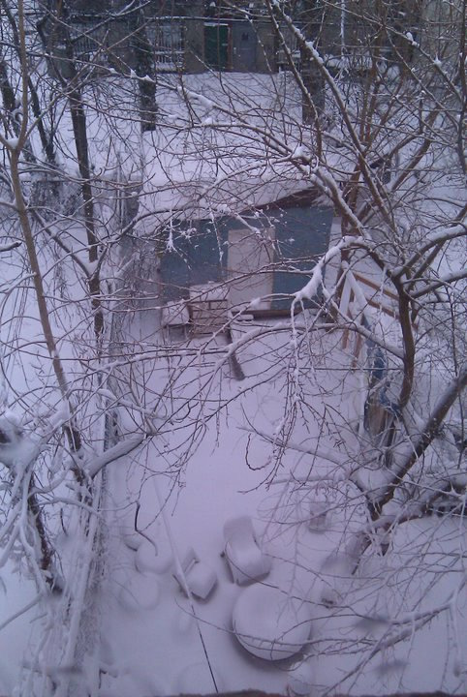

The Tiny House, February 2010.

The radical creativity of these communities is in no way being impinged here, quite the opposite. The expression ‘creative class’ is Richard Florida’s, and its significance will be discussed below.
Leif Jerram, “Space: A Useless Category for Historical Analysis?” History and Theory 52 (2013), 404.
Kathryne Beebe, Angela Davis and Kathryn Gleadle, “Introduction: Space, Place and Gendered Identities: feminist history and the spatial turn,” Women’s History Review 21, no. 4 (2012), 525.
Jasmine Mahmoud, “Brooklyn’s Experimental Frontiers: A Performance Geography,” TDR 58, no. 3 (Fall 2014), 112.
Mahmoud, “Brooklyn’s Experimental Frontiers,” 106.
Suleiman Osman, The Invention of Brownstone Brooklyn: Gentrification and the Search of Authenticity in Postwar New York (New York: Oxford University Press, 2011), 192-195; and, for Smith, see: Loretta Lees, Tom Slater, and Elvin Wyly, Gentrification (New York: Routledge, 2008), 224-225.
Mahmoud, “Brooklyn’s Experimental Frontiers,” 116.
See Author’s Online Archive, Queerspace: https://queerspace.commons.gc.cuny.edu/reference-1/
See Queerspace Archive: https://queerspace.commons.gc.cuny.edu/reference-2/
See, e.g.: Penelope Green, “A Modern Answer to the Commune,” New York Times, September 30, 2009 https://www.nytimes.com/2009/10/01/garden/01collective.html; Jed Lipinski, “A Commune Grows in Brooklyn,” New York Times, September 17, 2010 https://www.nytimes.com/2010/09/19/fashion/19Bushwick.html; Oriana Leckert, Brooklyn Spaces: 50 Hubs of Culture and Creativity (New York: Monacelli Press, 2015); Alex V. Barnard, Freegans: Diving into the Wealth of Food Waste in America (Minneapolis: University of Minnesota Press, 2016), 156-157; and, also: https://queerspace.commons.gc.cuny.edu/reference-3/
See Queerspace Archive: https://queerspace.commons.gc.cuny.edu/reference-4/
Jennifer Steinhauer, “Joblessness in Region Is Off Sharply,” New York Times. March 18, 2005; Jennifer Steinhauer, “Housing Boom Echoes in All Corners of the City,” New York Times, August 4, 2005.
Motoko Rich, “For Choicest Apartments, Many More Choices,” New York Times, November 10, 2005; Janny Scott, “Housing Tighter for New Yorkers of Moderate Pay,” New York Times, June 16, 2006.
Patrick McGeehan, “With Wall Street Slowing, Uncertainty Descends,” New York Times, October 22, 2007.
Barnard, Freegans, 158.
Sarah Schulman, The Gentrification of the Mind, (Berkeley: University of California Press, 2012), 81.
John D’Emilio, Sexual Politics, Sexual Communities: The Making of a Homosexual Minority in the United States, 1940-1970 (Chicago: University of Chicago Press, 1998), 119-122.
Credit: Diana, Jackie O., John B., June, Kelly, and Lila.
Credit: alessandra l., ariel p., callie p., chelsea m., diana r., gretel x., jackie o., julia p., merrill f., mieko b.
Hertz, Betti-Sue, and Ed Eisenberg, and Lisa Maya Knauer, “Queer Spaces in New York City: Places of Struggle/Places of Strength,” in Queers in Space: Communities, Public Places, Sites of Resistance, ed. Gordon Brent Ingram, Anne-Marie Bouthillette, and Yolanda Retter (Seattle: Bay Press, 1997), 364.
Eric O. Clarke, Virtuous Vice: Homoeroticism and the Public Sphere (Durham: Duke University Press, 2000), 5.
Hannah Dobbz, Nine-Tenths of the Law: Property and Resistance in the United States (Oakland: AK Press, 2012), 89.
Chris Hamnet, “The Blind Men and the Elephant: The Explanation of Gentrification,” Transactions of the Institute of British Geographers 16, 2 (1991), 174.
Loretta Lees, “A Reappraisal of Gentrification: Towards a ‘Geography of Gentrification,’ Progress in Human Geography 24, no. 3 (2000), 391.
Lees, “A Reappraisal of Gentrification,” 390.
Loretta Lees, “Rethinking Gentrification: Beyond the Positions of Economics or Culture,” Progress in Human Geography 18, no. 2 (1994), 143.
Lees, “Rethinking Gentrification,” 143.
Lees, “Rethinking Gentrification,” 143.
Neil Smith, The New Urban Frontier: Gentrification and the Revanchist City (New York: Routledge, 1996), 43.
Lees, “Rethinking Gentrification,” 142.
Lees, “Rethinking Gentrification,” 142.
Lees, “Rethinking Gentrification,” 142-143.
Lees, “Rethinking Gentrification,” 145.
Lees, “A Reappraisal of Gentrification,” 396.
Lees, “A Reappraisal of Gentrification,” 396.
David Ley, “The Rent Gap Revisited,” Annals of the Association of American Geographers 77, no. 3 (1987), 465.
Lees, Slater, and Wyly, Gentrification, 116.
Emanuela Guano, “Gentrification Without Teleologies,” in Creative Urbanity: An Italian Middle Class in the Shade of Revitalization (Philadelphia: University of Pennsylvania Press, 2017), 85.
Lees, Slater, and Wyly, Gentrification, 99-108, 213-214.
Neil Smith, The New Urban Frontier, 104-105.
Neil Smith, The New Urban Frontier, 104.
It might be difficult to determine the effective difference between such strategies, considered as an aspect of gentrification, and the bottom-up approach to housing advocated by John F.C. Turner.
Himadeep Muppidi, The Politics of the Global (Minneapolis: University of Minnesota Press, 2004), 25.
Neil Smith, The New Urban Frontier, xvi.
Artist Credit: Erin Ikeler.
Artist Credit: provenance uncertain.
Artist Credit: Area D.
Lees, Slater, and Wyly, Gentrification, 179-184.
Jerrold Seigel, Bohemian Paris: Culture, Politics, and the Boundaries of Bourgeois Life, 1830-1930 (Baltimore: John Hopkins University Press, 1986), 11.
John F.C. Turner, Housing By People: Towards Autonomy in Building Environments (London: Marion Boyars, 1976), xviii.
Alex V. Barnard, “Making the City ‘Second Nature’: Freegan ‘Dumpster Divers’ and the Materiality of Morality,” American Journal of Sociology 121, no. 4 (January 2016), 1019.
Dobbz, Nine-Tenths of the Law, 12.
Linda Martín Alcoff and José Alcoff, “Autonomism in Theory and Practice,” Science and Society 79, no. 2 (April 2015), 221-222.
See (or, perhaps, don’t) for instance, shows such as, ‘Tiny House Nation’ https://www.fyi.tv/shows/tiny-house-nation, and, ‘Tiny House, Big Living’ https://www.hgtv.com/shows/tiny-house-big-living.
Dobbz, Nine-Tenths of the Law, 35 and 85.
Photo Credit: provenance unknown.
Artist Credit: Area D.
Photo Credit: the author.
Dobbz, Nine-Tenths of the Law, 7.
Alcoff and Alcoff, “Autonomism in Theory and Practice,” 235.
Nick Crossley, Networks of Sound, Style and Subversion: The punk and post–punk worlds of Manchester, London, Liverpool and Sheffield, 1975–80 (Manchester: University of Manchester Press, 2015), 88.
Margaret Crawford, “Blurring the Boundaries: Public Space and Private Life,” in Everyday Urbanism, edited by John Leighton Chase, Margaret Crawford, and John Kaliski (New York: Monacelli Press, 2008), 35.
Gary Bridge, “Bourdieu, Rational Action and the Time-Space Strategy of Gentrification,” Transactions of the Institute of British Geographers 26, no. 2 (2001), 213.
See: Richard Florida, The Rise of the Creative Class (New York: Basic Books, 2002).
See above, p. 7.
Sharon Zukin, Naked City: The Death and Life of Authentic Urban Places (New York: Oxford University Press, 2010), 45.
See: Zukin, Naked City, 46-47.
Zukin, Naked City, 46.
Osman, The Invention of Brownstone Brooklyn, especially: Chapters 3 and 6.
Chris N. Burgess and David B. Pankratz, “Interrelations in the Arts and Creative Sector,” in Understanding the Arts and Creative Sector in the United States edited by Joni Maya Cherbo, Ruth Ann Stewart, Margaret Jane Wyszomirski (New Brunswick: Rutgers University Press, 2008), 35.
Ocean Howell, “The ‘Creative Class’ and the Gentrifying City: Skateboarding in Philadelphia’s Love Park,” Journal of Architectural Education 59, no. 2 (Nov., 2005), 39.
Sarah Schulman, The Gentrification of the Mind, 29.
David M. Halperin, Saint Foucault: Towards a Gay Hagiography (New York: Oxford University Press, 1995), 21.
Photo Credit: Jackie Doherty.

